Science 10 Review Test Name: ___________________

Part I. Matching: Put the letter of the best completion in the blank to the left of the term.
One term requires two answers.

______ Scalar A. is the change in position of an object.

______ Vector B. results from a change in the velocity.

______ Displacement C . can be calculated from a graph and is the same as average velocity.

______ Acceleration D. is a quantity requiring direction.

______ Velocity E. quantity would be something like time.

______ Slope F. is displacement relative to time.

G. A physical quantity that has magnitude but not direction is called

Part II Short Answer: Briefly answer each of the following in sentence form.

- a) What is the difference between precision and accuracy?

b) Give an example of precision.

- If a car has negative velocity, is it traveling to the west (left) or to the east (right)?

- If the graph of a car’s velocity has zero slope, what is the velocity of the vehicle?

- Give the formula for calculating slope.

- Give the formula for calculating velocity.

- What is the difference between instantaneous velocity and average velocity?

- List and describe two accurate timing devices.

- A physics teacher walks 4 meters East, 2 meters S, 4 meters W, and finally 2 meters N. Determine the distance traveled and the displacement.
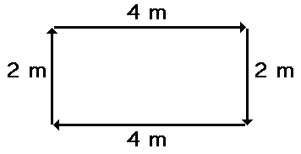

Distance = _____________ Displacement = _________

- The physics teacher walks 4 meters East, 2 meters South, 4 meters West, and finally 2 meters North. The entire motion lasted for 24 seconds. Determine the average speed and the average velocity.

Average speed = ___________ Average velocity = _________

10. Determine the velocity and slope of the object as portrayed by the graph below.
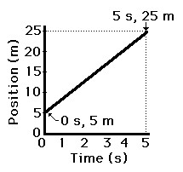

Slope = _________ m/s Velocity = ______________

Part III: Graphing. Plot the following points on a graph and answer the questions following.
- a) Mary travels to school on her scooter and the data for that movement is listed below.
Plot the data on graph paper.

 |  |  | t(s) | d(m)
 |  |  | 0 | -2
 |  |  | 1 | -1
 |  |  | 2 | 0
 |  |  | 3 | 2
 |  |  | 4 | 4
 |  |  | 5 | 6
 |  |  | 6 | 8
 |  |  | 7 | 8
 |  |  | 8 | 8
 |  |  | 9 | 8
 |  |  | 10 | 4
 |  |  | 11 | 0
 |  |  | 12 | -4
 |  |  | 13 | -3
 |  |  | 14 | -2

- Find the average velocity from 6 to 9 seconds.

- Find the average velocity between 9 and 12 seconds?

- Find the average velocity from 0 to 14 seconds.

- a) How far does a girl travel if she drives her car at 25.0 m/s for 8.00 minutes?

Given information:

Required to find:

Solve using the appropriate formula here:

Put your answer in a sentence here:

